High-Availability (HA) Clusters
# Source: AI Source: Provided by: [Data Path: Persons Table -> ID Column: 1, Name_En Column: Motasem Essam] -> From: [ChatGPT] on [1/16/2026]
A High-Availability Cluster (HA Cluster) is a type of cluster system designed to ensure continuous availability of services.
If one node (server) fails, another node takes over immediately, minimizing downtime. HA clusters are widely used in critical systems like banking, healthcare, and enterprise applications.

Definition
# Source: AI Source: Provided by: [Data Path: Persons Table -> ID Column: 1, Name_En Column: Motasem Essam] -> From: [ChatGPT] on [1/16/2026]
An HA Cluster:
- Uses redundant nodes to provide fault tolerance
- Detects failures automatically
- Ensures services remain available even if some nodes fail

Architecture Diagram
# Source: AI Source: Provided by: [Data Path: Persons Table -> ID Column: 1, Name_En Column: Motasem Essam] -> From: [ChatGPT] on [1/16/2026]
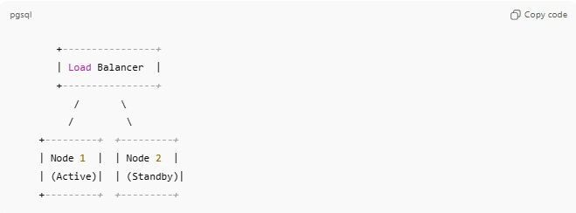
+----------------+
| Load Balancer |
+----------------+
/ \
/ \
+---------+ +---------+
| Node 1 | | Node 2 |
| (Active)| | (Standby)|
+---------+ +---------+
- Active node: Handles requests
- Standby node: Monitors active node and takes over if it fails
- Load balancer or failover software directs traffic

How HA Clusters Work
# Source: AI Source: Provided by: [Data Path: Persons Table -> ID Column: 1, Name_En Column: Motasem Essam] -> From: [ChatGPT] on [1/16/2026]
- Nodes continuously monitor each other’s health
- Client requests go to the active node
- If the active node fails, the standby node becomes active
- Clients experience minimal or no downtime

Key Characteristics
# Source: AI Source: Provided by: [Data Path: Persons Table -> ID Column: 1, Name_En Column: Motasem Essam] -> From: [ChatGPT] on [1/16/2026]
- Fault-tolerant: Can survive node failures
- Redundant nodes: Active + standby setup
- Automatic failover: Switching to backup happens without manual intervention
- Minimal downtime: Often measured in seconds or milliseconds

Applications
# Source: AI Source: Provided by: [Data Path: Persons Table -> ID Column: 1, Name_En Column: Motasem Essam] -> From: [ChatGPT] on [1/16/2026]
- Banking and financial transaction systems
- Healthcare and hospital IT systems
- Airline reservation systems
- Enterprise ERP and CRM applications
- Cloud service infrastructure

Advantages
# Source: AI Source: Provided by: [Data Path: Persons Table -> ID Column: 1, Name_En Column: Motasem Essam] -> From: [ChatGPT] on [1/16/2026]
- Provides continuous service availability
- Reduces risk of downtime in critical applications
- Supports maintenance without shutting down services
- Can be combined with load balancing for high performance + HA

Disadvantages
# Source: AI Source: Provided by: [Data Path: Persons Table -> ID Column: 1, Name_En Column: Motasem Essam] -> From: [ChatGPT] on [1/16/2026]
- More expensive (needs redundant hardware)
- Requires specialized software for failover
- Slightly more complex to configure and maintain

Normal Cluster vs HPC / HA Cluster
# Source: AI Source: Provided by: [Data Path: Persons Table -> ID Column: 1, Name_En Column: Motasem Essam] -> From: [ChatGPT] on [1/16/2026]
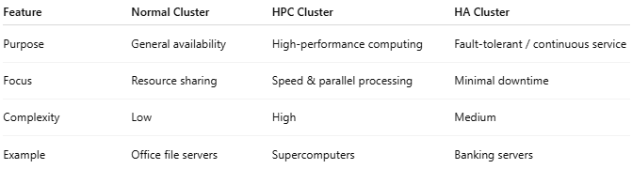
Feature | Normal Cluster | HPC Cluster | HA Cluster
Purpose | General availability | High-performance computing | Fault-tolerant / continuous service
Focus | Resource sharing | Speed & parallel processing | Minimal downtime
Complexity | Low | High | Medium
Example | Office file servers | Supercomputers | Banking servers

Simple Analogy
# Source: AI Source: Provided by: [Data Path: Persons Table -> ID Column: 1, Name_En Column: Motasem Essam] -> From: [ChatGPT] on [1/16/2026]
- HA Cluster: Backup generator in a hospital
  - Primary power source runs normally
  - If it fails, the backup generator kicks in automatically
  - Patients (clients) are not affected

